Document Management
Physical Archiving of Documents
Introduction: Managing the physical record has always been a problem for both public and private sector organizations. Older the organization grows more difficult is to store and maintain these records. Management and maintenance of records for normally gains a complex dimension; as critical and classified records are required to be stored as per audit, regulatory or SECP requirements for a protracted period up to ten years.

Kiosk Solutions Offers Software Based Solution: which works on the principle similar to
library cataloguing and indexing with the core objective to automate Commercial
Bank’s document storage facility and transform it into a state of art warehouse.
Salient features of this solution are:-
- Automated Storage - Kiosk Solutions has developed a software based system for Document storage/Archiving. It is an automated solution with indexing & cataloging feature and to this effect a database is created. All types of documents are stored and with their types and categories.
- Types and Entity of Documents is Maintained: System also gives the status of all types of documents and generates reports for management. It also facilitates tracking of documents life and warning indication is generated once documents are due for destruction, ensuring their timely disposal/destruction.
- Quick Tracking & Retrieval – being software based system, with proper cataloguing; the records are stored in boxes with proper tracking mechanism thus facilitating quick retrieval.
- Storage Facility – Two options are available:
- Storage in Box Files: Records are stored in Box files, and placed in shelves with indexing & cataloging feature
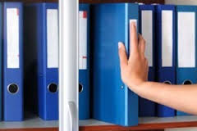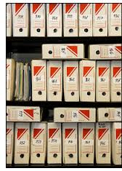

- Storage in Boxes: Records and documents can be stored in cartons (card board boxes) & placed on shelves/racks for proper & organized storage. Once these boxes are sealed there is no chance of misplacement, theft, forgery subsequent addition/deletion in sensitive records.

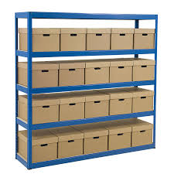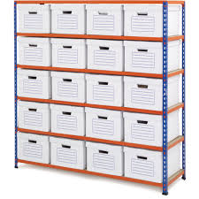

- Types and Entity of Documents is Maintained: System also gives the status of all types of documents and generates reports for management. It also facilitates tracking of documents life and warning indication is generated once documents are due for destruction, ensuring their timely disposal/destruction.
- Secure, Protected and Environmental Friendly Storage – the storage site is made secure through controlled access, camera based monitoring, and fire suppression system. All access points to storage facility are alarmed, monitored and recorded. In addition Stored material is protected against all type of environmental hazards like dampness, termite and natural decay of paper has been ensured through storing in boxes made for this purpose. To avoid paper decay ante termite/insects & rodent control measures are implemented.

Software Features
- Integrated Archiving Solution: The salient functionalities of the Archiving solution includes following:-
- Creation of Initial Database; understands that initial database created will serve as a premature optimization.
- Reporting Tool; the solution will be embedded in Microsoft Reporting tool, which will generate the desired reports; both adhoc and custom built. Provided full details of reporting dimensions, the software smartly generates and deliver those reports.
- Carries out indexing & cataloging of all the files, documents/cartons.
- Automatically allocate shelf and rack.
- Facilitates “one click” retrieval.
- Keeps track of documents life and generates report once documents are due for destruction, as well indicating documents location.
- Keeps track of all documents retrieved and returned to the store.
- Technology: The software has been developed in Dot.Net with MS SQL or My SQL database, as per client’s requirement. The solution will be fully;
  - Compatible with Windows Operating System (Server & Client)
  - Operate able in client server environment
  - Developed in Microsoft platform
Offer
The core objective of this offer is to automate public and private sector document storage facility and transform it into a state of art warehousing. In case, an organization opt with the idea of automating their storage facility where critical, auditable, classified physical records are stored; Kiosk Solutions will arrange a detailed presentation to explain the whole concept, and clarify further doubts.

Contact Person
_______________________________________________
Lt Col Khalid Hameed Shah (R) Shaheryar Bhatty
Executive Director Manager Business Development
Kiosk Solutions Kiosk Solutions
Ph: 0300-8565031 Ph: 0333-2179193
URL: www.kiosksolutions.com.pk URL: www.kiosksolutions.com.pk
e-mail: khalid@kiosksolutions.com.pk e-mailshaheryar@kiosksolutions.com.pk

